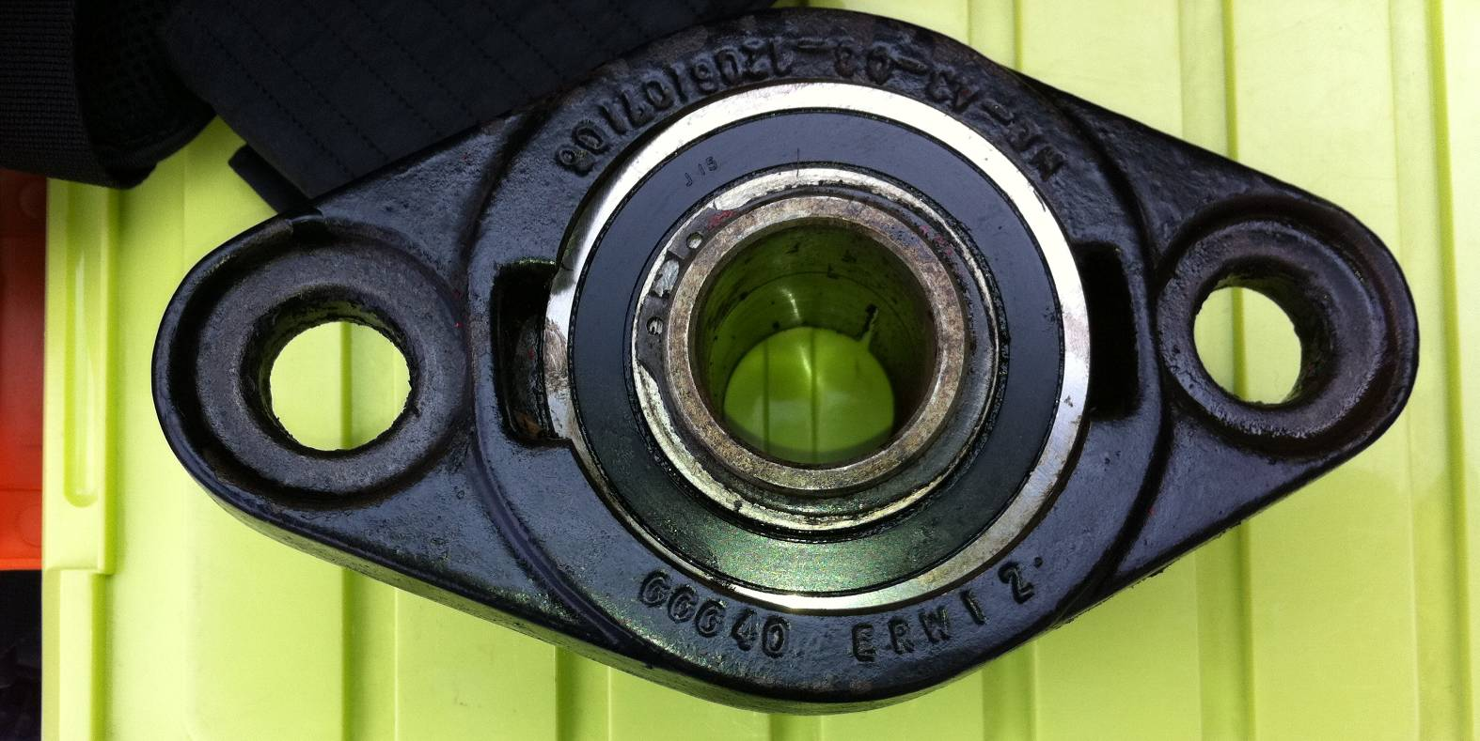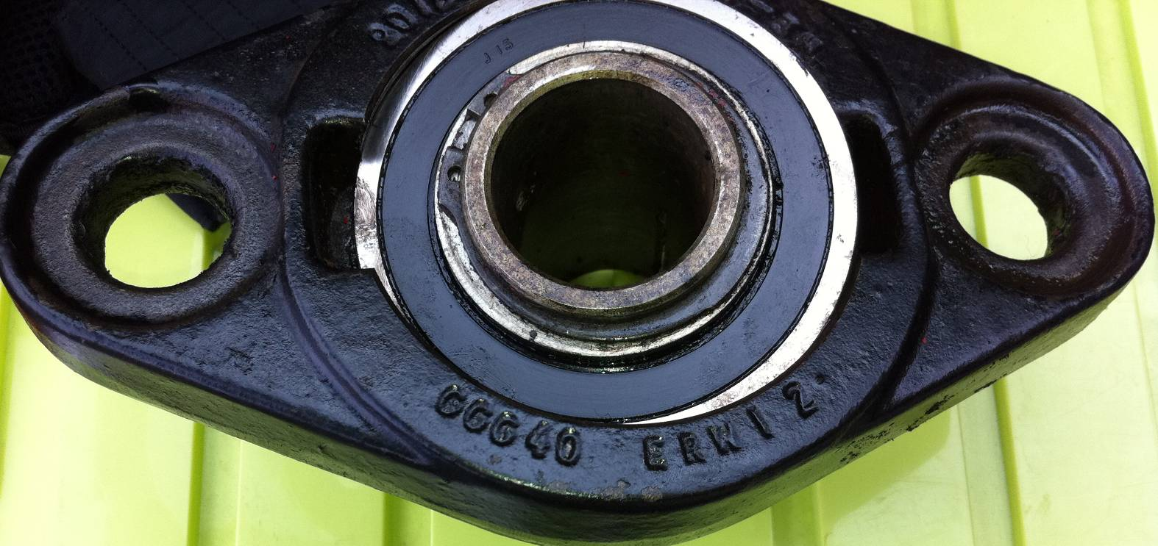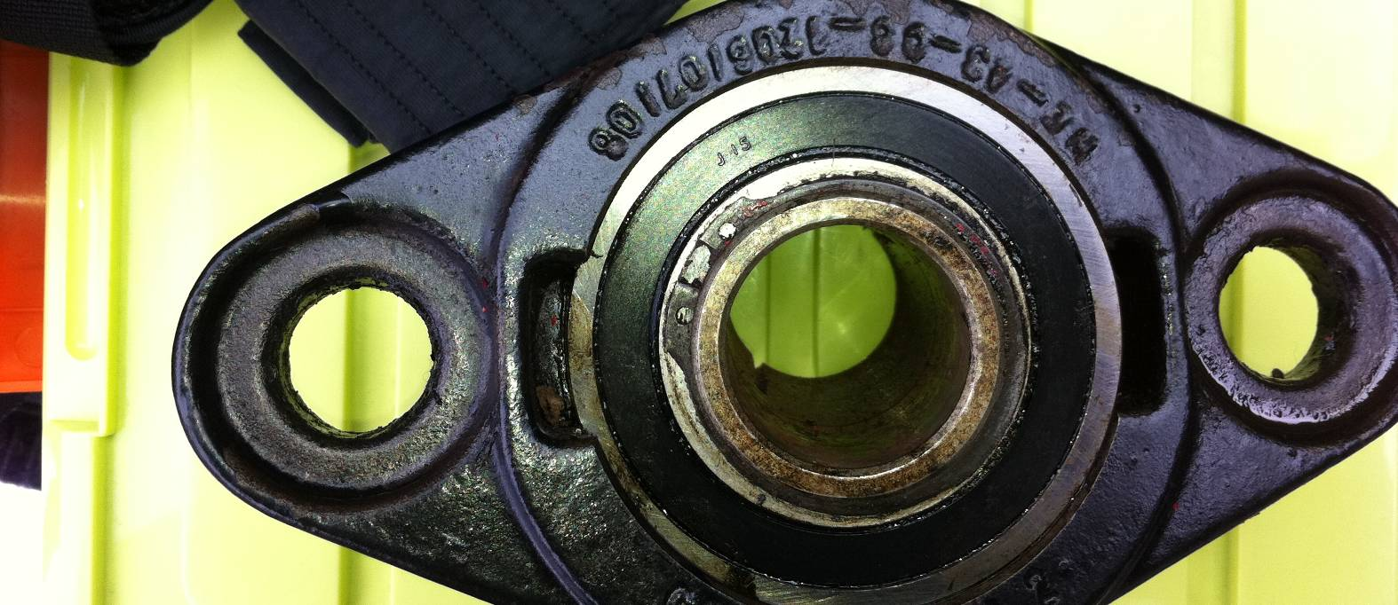
Simply Bearings

UCFL207 Metric Two Bolt Oval Cast Iron Flange Housing with 35mm Bore Insert  Also Known As: SFT35 |  | £16.40  ex. VAT

http://simplybearings.co.uk/shop/Housings+&+Inserts-Housings/c16_17/p21484/UCFL209+Metric+Two+Bolt+Oval+Cast+Iron+Flange+Housing+with+45mm+Bore+Insert/product_info.html

UCFL209 Metric Two Bolt Oval Cast Iron Flange Housing with 45mm Bore Insert  Also Known As: SFT45 |  | £23.73  ex. VAT

