
Leece•NeviIIe
HEAVY DUTY SYSTEMS
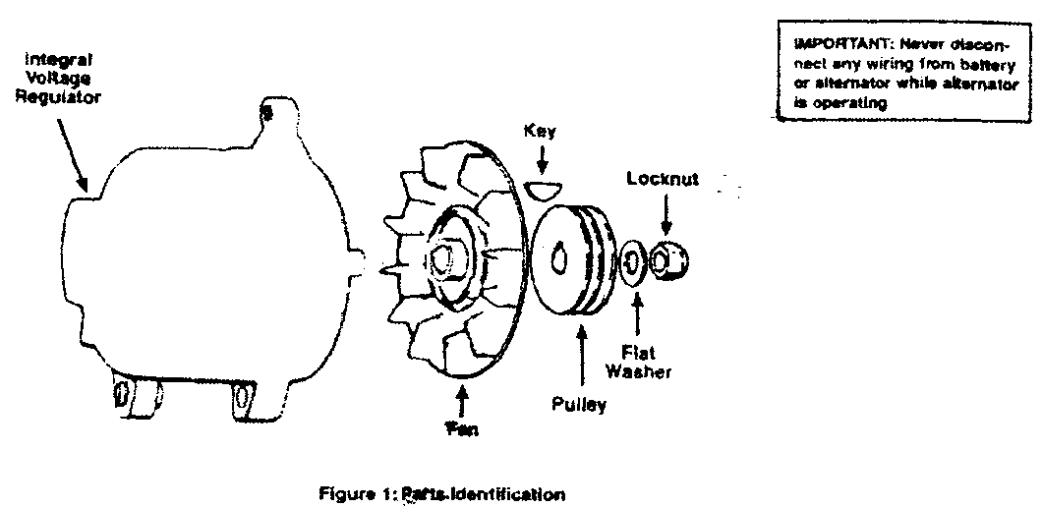

General Information
Heavy duty, electronic alternator system designed for use with both positive and negative ground systems.
This alternator is equipped with a bi-directional fan which can rotate in either a clockwise or counter-clockwise direction. A suitable pulley may be purchased from your local Leece-Neville dealer — See Section 1. For operation in hazardous atmosphere, it has a completely enclosed brush assembly to prevent slip ring contamination and to shield any arcing. The rectifier assembly contains 3 positive and 3 negative diodes to provide more than ample current handling capability. The stator is insulated to provide maximum protection against shorting of the windings to the lamination. The stator has 3 AC tap (R) terminals that can be used for tachometer input.
The alternator has a 7/8” shaft and a No. 305 bearing on the [rive end. The rear bearing is fully sealed and permanently lubricated for the life of the bearing.
This alternator includes a fully transistorized integral voltage regulator, preset at 14.2 volts, which performs all of the operations necessary for complete control of the alternator output. The system is temperature compensated to permit the ideal charging rate at all temperatures. It is capable of operating in an ambient temperature of 100 C to 40 C.
If an ammeter is desired, Leece-Neville recommends the use of a good quality ammeter with a full scale slightly larger than the alternator’s output rating. Two types are available; direct connected (where the current passes through the meter); and shunt (remote) types. If the direct type is selected, a quantity of proper size wire sufficient to run from the output terminal of the alternator, up to the meter and back to the battery may be supplied with the meter or may have to be obtained. (See table below for proper wire size for required length). Consult ammeter installation
Wire Length | Less than 16ft | 16-25ft | 25-40ft
Wire Size | #0 | #0 | #00
Installation Instructions
110-555, 8LHA2O7OVB
14 Volt / 140 Amp
_____________________________________________

Section I — Pulley Selection
Several pulleys are available from your Leece-Neville dealer to fit a wide variety of applications. There are single and double grooved pulleys which fit standard belt sizes from 3/8” to 11/16”, and serpentine pulleys for belts up to 8 grooves. Pulley blanks into which grooves must be cut to fit special bell sizes, are also available.
In addition, any pulley which fits a standard 7/8” shaft can be used. For machining instructions on other than a standard pulley, refer to Figure 2. The pulley is installed on the machine by removing the washer, locknut, and protective composition sleeve and then assembling the pulley on the shaft and tightening in place wit the washer and locknut.
NOTE: Torque on pulley locknut — mm. 40 to 50 ft. lbs. Maximum not to exceed stamped rating on fan. Failure to regulate torque on impact wrench may result in damaged shaft. Also use pulley nut supplied wit alternator.
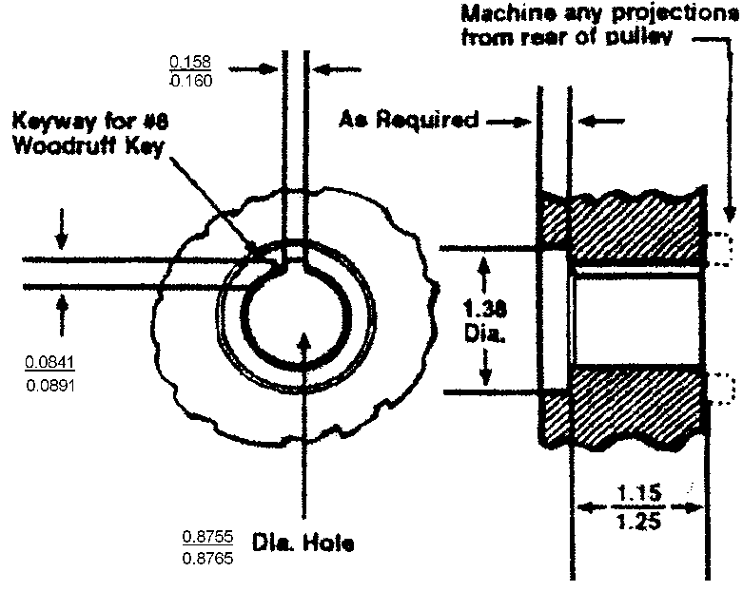
Figure 2 Shaft Dimension Detail

Section II— Mounting of Alternator
After the alternator mounting location has been determined, loosely attach the mounting bracket to the engine with the mounting bracket bolts. Position the alternator mounting foot between the 2 ears on the mounting bracket with the alternator mounting bolts. Align the alternator pulley with the engine drive pulley as shown in Figure 3 and tighten the bracket mounting bolts, securing the mounting bracket to the engine. Loosely attach the alternator adjustment bracket to the alternator adjustment ear with the bolt, lockwasher and flat washer. Tighten the fan belt by applying pressure to the alternator front housing only and tighten the bolt to the adjustment ear. Tighten the alternator mounting bolts and retighten all other bolts to secure the installation.
CAUTION: Alternator will be permanently damaged if pressure is applied to rear housing. Tighten the fan belt by pressing against front casting near alternator fan.
Set belt tension per belt manufacturer’s recommended specifications, and tighten all remaining bolts (contact manufacturer for specifications). If manufacturer’s specifications are not readily available, set belt tension tight enough so that the belt on alternator fan pulley will not slip when attempting to rotate alternator fan by hand.
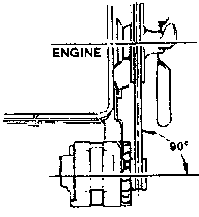
Alternator Pulley and Drive Pulley Must Be In line With Each Other
Figure 3: Alternator Mounting
CAUTION: Alternator drive belts do stretch, particularly when they are new. Recheck belt tension from time to time. Belt slippage is more likely to occur with an alternator because of heavy charge rate possible at engine idle.

Section III — Electrical Connections
Disconnect cables from battery before making following electrical connections.
- Connect the existing alternator output to the output terminal of the alternator. Be certain that the proper size wire is used to carry full output current to the battery. Connect ground to alternator.
- Turn off all switches and electrical loads. Replace one cable on battery. Momentarily touch second terminal to other battery post. If no spark occurs, fasten cables to battery posts. If a spark occurs, recheck polarity of battery and all above steps until the fault is found.
WARNING: Reverse polarity of battery connections will cause damage to the rectifier diodes in the alternator. Be sure to check wiring before making battery connections.

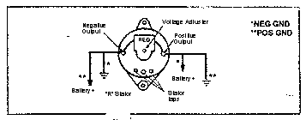

Section IV Proper Ammeter Indication
After engine is started, the ammeter will usually show a rather heavy charge for a short time. The transistor regulator is permitting the alternator to charge heavily to replace the power taken from the battery during starting.
As the engine continues to operate, the amperes of charge will gradually drop to 0 to 4 amps as the battery becomes fully charged. This may take anywhere from 15 minutes to a few hours and will depend on the size and condition of the battery.
If a heavy electrical load (like a number of floodlights, an electric hoist, motor, etc.) is turned on, the ammeter may show less charge or even discharge for a while. This is a normal condition even if the load is only 40 to 50 amps.
If the load remains on, the amount of discharge will decrease and soon the ammeter will show a slight charge. If the load is now turned off, the ammeter will show a heavy charge for a short while and then gradually return to near zero. This is also a normal condition
If the ammeter shows a continuing high charge rate, 10 to 20 or more ampere, for long periods of time, the condition of the batteries should be checked.
If the ammeter shows a slight discharge consistently when the engine is operating at normal speeds, turn off all electrical loads, except ignition, for a few seconds. If ammeter jumps up to 30 to 85 amp charge, system is normal — the electrical loads are just absorbing all the alternator can generate. However, if ammeter should still show a slight discharge of 2 to 8 amps, there is a problem in the charging system. It is likely that the drive belt is either slipping or broken). If belt is okay, check for loose or broken electrical wires.
If the engine is required to run at slow idle for long periods while heavy electrical loads are demanded, the ammeter should be observed from time to time. If the ammeter shows a heavy discharge (more than 10 amps), it would be wise to increase the idle speed of the engine sufficiently to bring the ammeter to zero or to show a slight charge.
Keep in mind that when the batteries are normal and well charged, the ammeter should rest near zero, or show a very slight charge. With a transistor voltage regulator, there may be very little or no motion of the ammeter needle. This is also normal because the transistors maintain the voltage very consistently and smoothly.

